**SR-Annu**  [11:37 AM](https://ncs--program.slack.com/archives/C056KBW1N0M/p1683698853022629)

<https://angular.io/>

**angular.io**

[**Angular**](https://angular.io/)

Angular is a platform for building mobile and desktop web applications.  
Join the community of millions of developers who build compelling user interfaces with Angular.

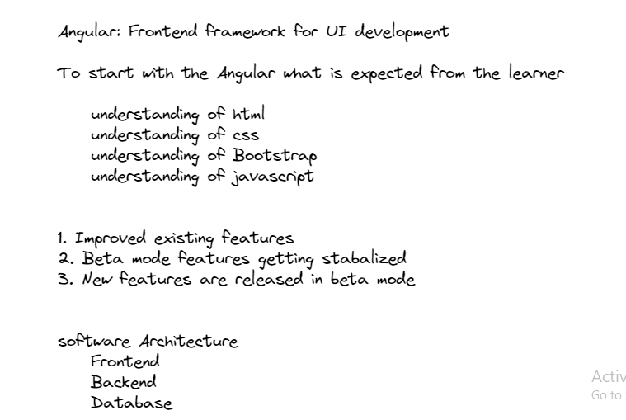

**SR-Annu**  [12:43 PM](https://ncs--program.slack.com/archives/C056KBW1N0M/p1683702798798909)

<https://www.typescriptlang.org/docs/>

**typescriptlang.org**

[**The starting point for learning TypeScript**](https://www.typescriptlang.org/docs/)

Find TypeScript starter projects: from Angular to React or Node.js and CLIs.

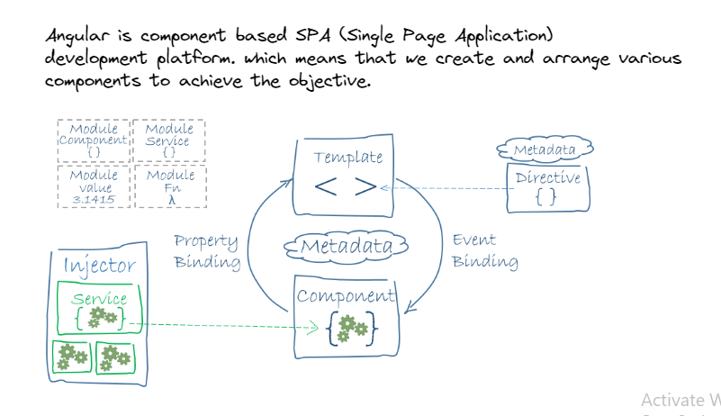

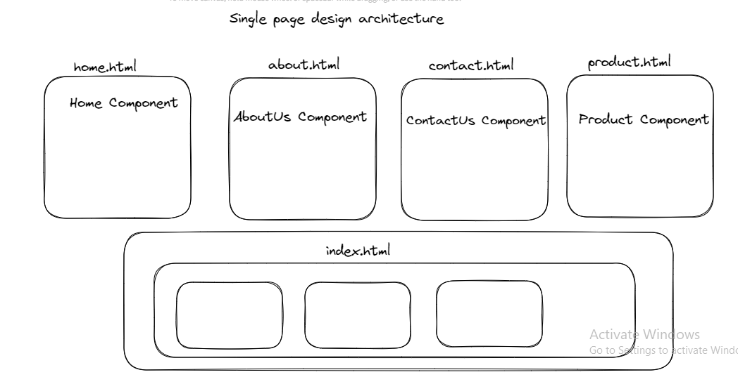

**SR-Annu**  [3:20 PM](https://ncs--program.slack.com/archives/C056KBW1N0M/p1683712241364789)

<https://angular.io/guide/file-structure>

**angular.io**

[**Angular**](https://angular.io/guide/file-structure)

Angular is a platform for building mobile and desktop web applications.  
Join the community of millions of developers who build compelling user interfaces with Angular.

**SR-Annu**  [4:58 PM](https://ncs--program.slack.com/archives/C056KBW1N0M/p1683718123561399)

<https://angular.io/cli/serve>

**angular.io**

[**Angular**](https://angular.io/cli/serve)

Angular is a platform for building mobile and desktop web applications.  
Join the community of millions of developers who build compelling user interfaces with Angular.

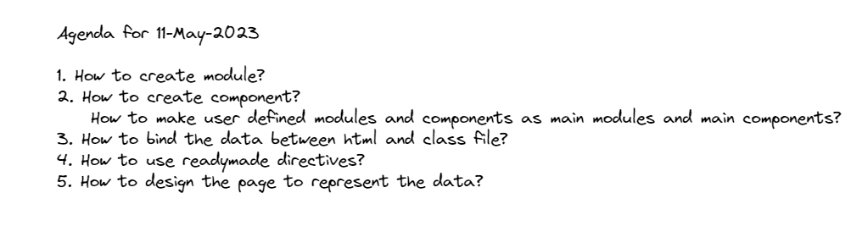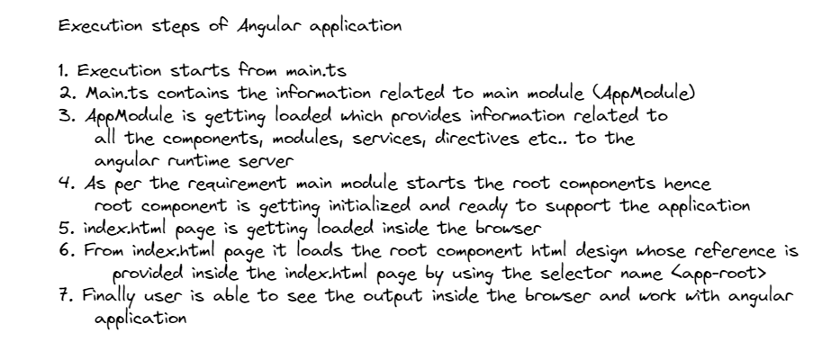

**SR-Annu**  [12:21 PM](https://ncs--program.slack.com/archives/C056KBW1N0M/p1683787893581999)

<https://angular.io/guide/structural-directives>

**angular.io**

[**Angular**](https://angular.io/guide/structural-directives)

Angular is a platform for building mobile and desktop web applications.  
Join the community of millions of developers who build compelling user interfaces with Angular.



**SR-Annu**  [1:00 PM](https://ncs--program.slack.com/archives/C056KBW1N0M/p1683790234394669)

<h1>!!! Student Details By using switch case !!!</h1>

<ul \*ngFor="let stdObj of stdList" class="list-group" [ngSwitch]="stdObj.stdCountry">

<li class="list-item-group text-success" \*ngSwitchCase="'USA'">

{{stdObj.stdName}}

{{stdObj.stdEmail}}

{{stdObj.stdCountry}}

{{stdObj.stdMarks}}

</li>

<li class="list-item-group text-primary" \*ngSwitchCase="'Indi'">

{{stdObj.stdName}}

{{stdObj.stdEmail}}

{{stdObj.stdCountry}}

{{stdObj.stdMarks}}

</li>

</ul>

<hr>

<h1>!!! Student Details By using Loop, conditions and styles USA!!!</h1>

<ul \*ngFor="let stdObj of stdList" class="list-group">

<li class="list-item-group" \*ngIf="stdObj.stdCountry=='USA'">

{{stdObj.stdName}}

{{stdObj.stdEmail}}

{{stdObj.stdCountry}}

{{stdObj.stdMarks}}

</li>

</ul>

<hr>

<h1>!!! Student Details By using Loop, conditions and styles!!!</h1>

<ul \*ngFor="let stdObj of stdList" class="list-group">

<li class="list-item-group">

{{stdObj.stdName}}

{{stdObj.stdEmail}}

{{stdObj.stdCountry}}

{{stdObj.stdMarks}}

</li>

</ul>

<hr>

<h1>!!! Student Details By using Loop!!!</h1>

<ul \*ngFor="let stdObj of stdList">

<li>{{stdObj.stdName}}</li>

<li>{{stdObj.stdEmail}}</li>

<li>{{stdObj.stdCountry}}</li>

<li>{{stdObj.stdMarks}}</li>

</ul>

<hr>

<h1>!!! Student Details !!!</h1>

<ul>

<li>{{stdList[0].stdName}}</li>

<li>{{stdList[0].stdEmail}}</li>

<li>{{stdList[0].stdCountry}}</li>

<li>{{stdList[0].stdMarks}}</li>

<li>{{stdList[1].stdName}}</li>

<li>{{stdList[1].stdEmail}}</li>

<li>{{stdList[1].stdCountry}}</li>

<li>{{stdList[1].stdMarks}}</li>

<li>{{stdList[2].stdName}}</li>

<li>{{stdList[2].stdEmail}}</li>

<li>{{stdList[2].stdCountry}}</li>

<li>{{stdList[2].stdMarks}}</li>

<li>{{stdList[3].stdName}}</li>

<li>{{stdList[3].stdEmail}}</li>

<li>{{stdList[3].stdCountry}}</li>

<li>{{stdList[3].stdMarks}}</li>

</ul>

[1:00](https://ncs--program.slack.com/archives/C056KBW1N0M/p1683790249473809)

Use it inside Student.component.html

[1:01](https://ncs--program.slack.com/archives/C056KBW1N0M/p1683790261071939)

h1

{

text-align: center;

}

ul

{

text-decoration: none;

text-align: center;

}

li

{

text-decoration: none;

text-align: center;

}

[1:01](https://ncs--program.slack.com/archives/C056KBW1N0M/p1683790270556469)

Use it inside Student.component.css

[1:01](https://ncs--program.slack.com/archives/C056KBW1N0M/p1683790282273449)

constructor()

{

this.stdList=[

{

"stdName":"Tim",

"stdEmail":"tim@gmail.com",

"stdCountry":"India",

"stdMarks":450,

},

{

"stdName":"Rim",

"stdEmail":"rim@gmail.com",

"stdCountry":"India",

"stdMarks":350,

},

{

"stdName":"Jim",

"stdEmail":"jim@gmail.com",

"stdCountry":"USA",

"stdMarks":500,

},

{

"stdName":"Kim",

"stdEmail":"kim@gmail.com",

"stdCountry":"USA",

"stdMarks":400,

}

];

}



[1:01](https://ncs--program.slack.com/archives/C056KBW1N0M/p1683790303010269)

Use it inside StudentComponent class

**SR-Annu**  [9:39 AM](https://ncs--program.slack.com/archives/C056KBW1N0M/p1683864561893699)

<https://angular.io/guide/lifecycle-hooks>

**angular.io**

[**Angular**](https://angular.io/guide/lifecycle-hooks)

Angular is a platform for building mobile and desktop web applications.  
Join the community of millions of developers who build compelling user interfaces with Angular.

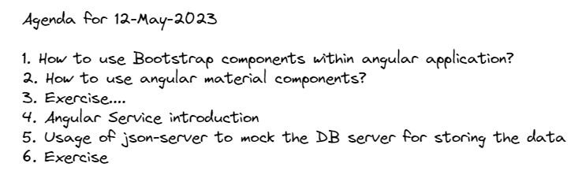

**SR-Annu**  [10:48 AM](https://ncs--program.slack.com/archives/C056KBW1N0M/p1683868729108889)

<https://www.w3.org/standards/webdesign/htmlcss>

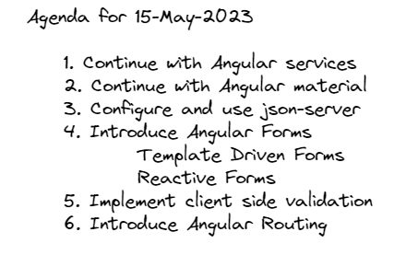

**SR-Annu**  [10:02 AM](https://ncs--program.slack.com/archives/C056KBW1N0M/p1684125170235479)

<https://angular.io/guide/forms-overview>

**angular.io**

[**Angular**](https://angular.io/guide/forms-overview)

Angular is a platform for building mobile and desktop web applications.  
Join the community of millions of developers who build compelling user interfaces with Angular.

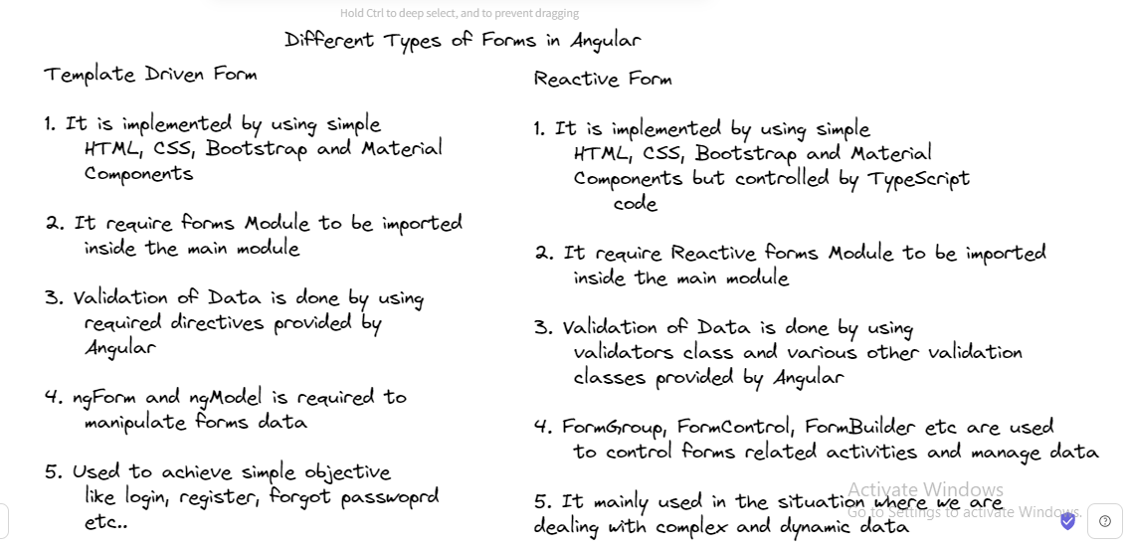

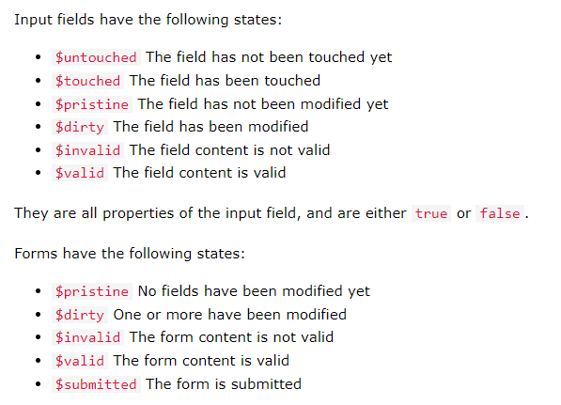

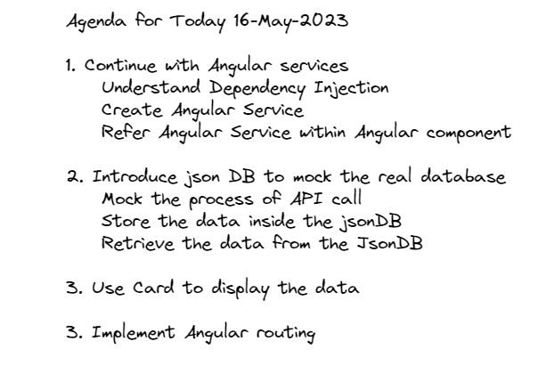

**SR-Annu**  [10:54 AM](https://ncs--program.slack.com/archives/C056KBW1N0M/p1684214684914099)

<https://angular.io/guide/observables-in-angular>

**angular.io**

[**Angular**](https://angular.io/guide/observables-in-angular)

Angular is a platform for building mobile and desktop web applications.  
Join the community of millions of developers who build compelling user interfaces with Angular.

[10:54](https://ncs--program.slack.com/archives/C056KBW1N0M/p1684214692279359)

<https://angular.io/guide/architecture-services>

**angular.io**

[**Angular**](https://angular.io/guide/architecture-services)

Angular is a platform for building mobile and desktop web applications.  
Join the community of millions of developers who build compelling user interfaces with Angular.

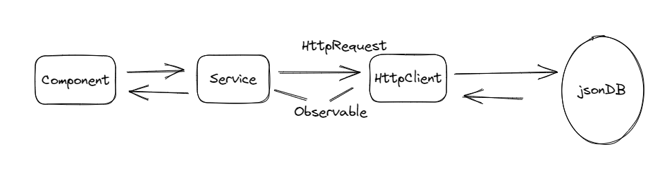

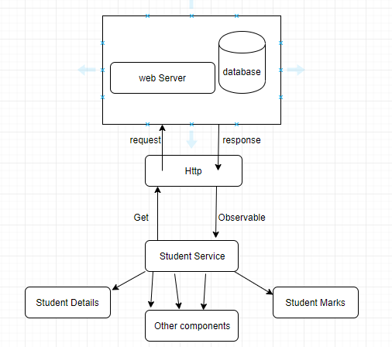

<div class="notecard-container">

<mat-card class="note-card" \*ngFor="let noteObj of noteList">

<mat-card-header>

<mat-card-title>{{noteObj.noteTitle}}</mat-card-title>

</mat-card-header>

<mat-card-content>

<p>{{noteObj.noteDesc}}</p>

</mat-card-content>

<mat-card-actions>

<button mat-button>LIKE</button>

<button mat-button>SHARE</button>

</mat-card-actions>

</mat-card>

</div>

[2:37](https://ncs--program.slack.com/archives/C056KBW1N0M/p1684228064612949)

import {MatCardModule} from '@angular/material/card';

[2:38](https://ncs--program.slack.com/archives/C056KBW1N0M/p1684228080181699)

.notecard-container

{

display: flex;

flex-direction: row;

flex-wrap: wrap;

margin-top: 2%;

margin-left: 5%;

}

.note-card

{

display: flex;

flex-direction: column;

width: 200px;

height: 150px;

padding: 1%;

margin: 1%;

}

[2:39](https://ncs--program.slack.com/archives/C056KBW1N0M/p1684228171865279)

<https://angular.io/guide/routing-overview>

**angular.io**

[**Angular**](https://angular.io/guide/routing-overview)

Angular is a platform for building mobile and desktop web applications.  
Join the community of millions of developers who build compelling user interfaces with Angular.



**SR-Annu**  [2:49 PM](https://ncs--program.slack.com/archives/C056KBW1N0M/p1684228779527739)

{path:'',redirectTo:"login",pathMatch:"full"},

{path:'login',component:LoginComponent},

{path:'note',component:NoteComponent}

[2:52](https://ncs--program.slack.com/archives/C056KBW1N0M/p1684228960575329)

1. Create register component

2. Allow user to register and data will be stored inside the jsonDB

3. Admin should be able to see all the users registered

4. Allow the user to login, validate the user based userid and password

provided while registration

5. Implement routing so that user can navigate to respective component page

as and when required

[2:53](https://ncs--program.slack.com/archives/C056KBW1N0M/p1684229032753309)

<a mat-list-item routerLink="login">Login</a>

<a mat-list-item routerLink="note">Notes</a>

[2:54](https://ncs--program.slack.com/archives/C056KBW1N0M/p1684229042333119)

<router-outlet></router-outlet>



**SR-Annu**  [4:06 PM](https://ncs--program.slack.com/archives/C056KBW1N0M/p1684233396939969)

<https://gitlab.stackroute.in/stack_angularv7_keep/angular7-keep-level-1-assignment.git>

[4:07](https://ncs--program.slack.com/archives/C056KBW1N0M/p1684233437149659)

I have released the first assignment of Angular

[4:07](https://ncs--program.slack.com/archives/C056KBW1N0M/p1684233448396219)

Request you to first fork this link

[4:07](https://ncs--program.slack.com/archives/C056KBW1N0M/p1684233464490309)

Then Clone, After that read the problem statement

[4:07](https://ncs--program.slack.com/archives/C056KBW1N0M/p1684233477506689)

Then start working towards the solution

[4:08](https://ncs--program.slack.com/archives/C056KBW1N0M/p1684233485603379)

let me know in case any doubt

[4:08](https://ncs--program.slack.com/archives/C056KBW1N0M/p1684233489800839)

Thanks



**SR-Annu**  [4:15 PM](https://ncs--program.slack.com/archives/C056KBW1N0M/p1684233919593579)

Dynamic Routing

[4:15](https://ncs--program.slack.com/archives/C056KBW1N0M/p1684233920849429)

constructor(private router:Router)

[4:15](https://ncs--program.slack.com/archives/C056KBW1N0M/p1684233927727849)

this.router.navigate(["note"]);

**SR -Anisha**  [4:14 PM](https://ncs--program.slack.com/archives/C056KBW1N0M/p1684320290652129)

<https://stackbooks.stackroute.in/course/Building-Single-Page-Applications-Using-Angular/index>

**GitLab**

[**Sign in**](https://stackbooks.stackroute.in/course/Building-Single-Page-Applications-Using-Angular/index)

Private Source Code Repository of StackRoute



**SR-Annu**  [10:29 AM](https://ncs--program.slack.com/archives/C056KBW1N0M/p1684385982390229)

<https://insomnia.rest/download>

**insomnia.rest**

[**Download**](https://insomnia.rest/download)

Download Insomnia the best API Client for REST, GraphQL, GRPC and OpenAPI design tool for developers (179 kB)

**SR-Annu**  [2:24 PM](https://ncs--program.slack.com/archives/C056KBW1N0M/p1684400084145079)

<https://rxjs.dev/guide/operators>



**SR-Annu**  [9:39 AM](https://ncs--program.slack.com/archives/C056KBW1N0M/p1684469364601269)

<https://gitlab.stackroute.in/stack_angularv7_keep/angular7-keep-level-2-assignment>

**SR-Annu**  [2:33 PM](https://ncs--program.slack.com/archives/C056KBW1N0M/p1684487021698449)

<https://jasmine.github.io/>



**SR-Annu**  [2:58 PM](https://ncs--program.slack.com/archives/C056KBW1N0M/p1684488513699379)

<https://jasmine.github.io/api/edge/matchers.html>

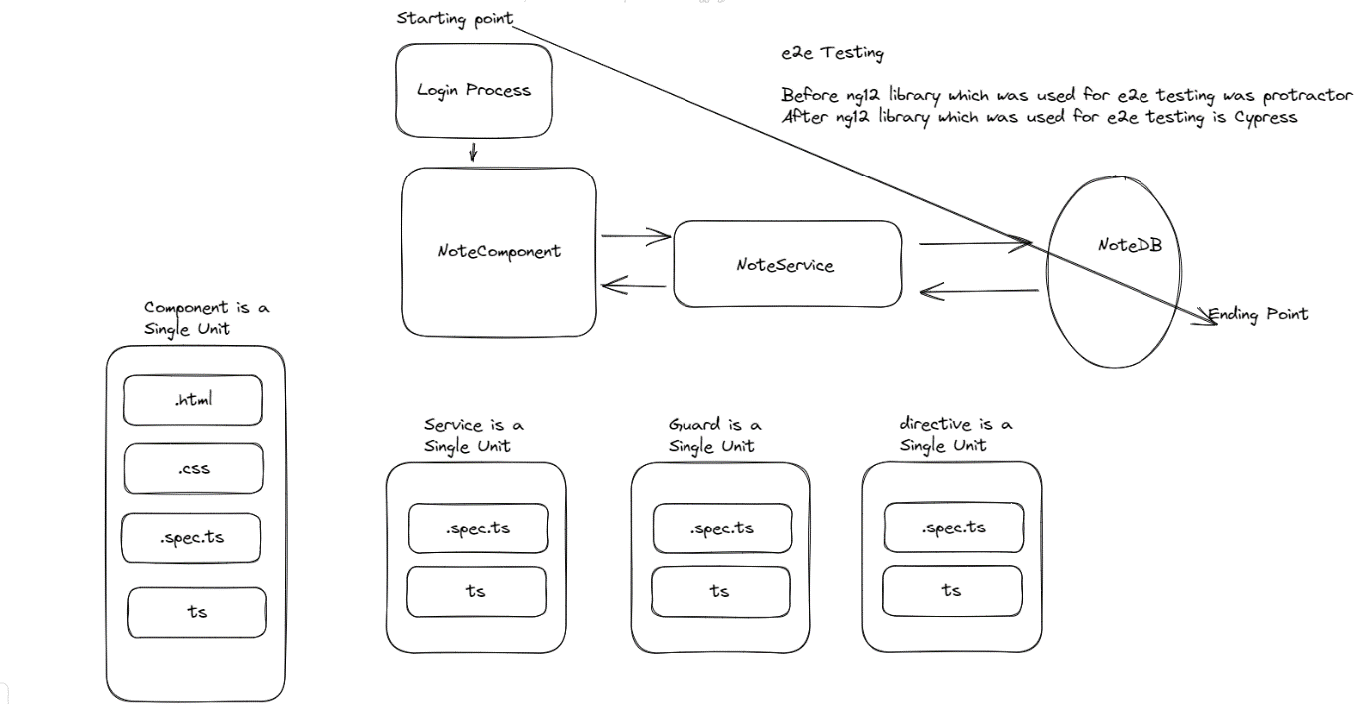

<https://www.cypress.io/>

**Cypress**

[**JavaScript Component Testing and E2E Testing Framework | Cypress**](https://www.cypress.io/)

Cypress' open-source app takes the pain out of front-end testing. Use the Cypress E2E testing framework for any application or component that runs in a browser. (111 kB)

**SR-Annu**  [4:30 PM](https://ncs--program.slack.com/archives/C056KBW1N0M/p1684753246190269)

<https://medium.com/@daniel.glejzner/angular-16-is-out-now-learn-how-to-replace-rxjs-with-signals-c1f6f410809>

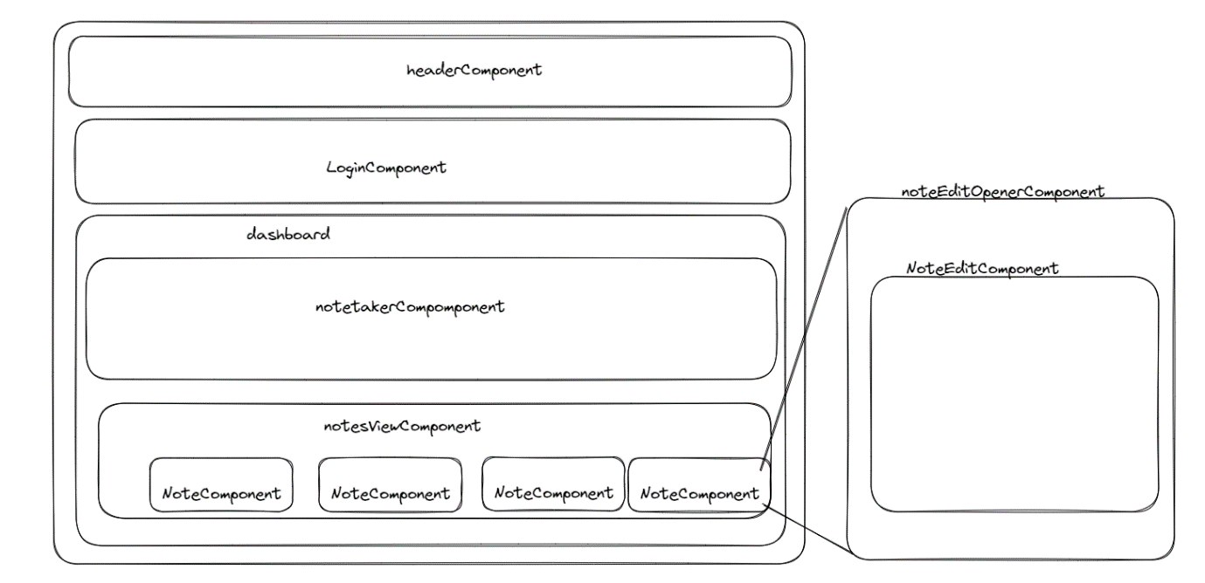

**SR-Annu**  [12:31 PM](https://ncs--program.slack.com/archives/C056KBW1N0M/p1684825262175399)

<https://rxjs.dev/api/operators/tap>

**SR-Annu**  [2:43 PM](https://ncs--program.slack.com/archives/C056KBW1N0M/p1684833236674059)

<https://gitlab.stackroute.in/stack_angularv7_keep/angular7-keep-level-3-assignment.git>

**GitLab**

**SR-Annu**  [10:16 AM](https://ncs--program.slack.com/archives/C056KBW1N0M/p1684989994060139)

Advance Java Concepts:

Collections, Generics

Overview of Threading, Multithreading

Hibernate ORM

New Java Features:

Interface Enhancements; Functional Interfaces; Lambda Expression; ForEach – Iterable; Method References;

Stream API, Filters, Date Time

Java Testing and code coverage:

Unit Testing with JUnit

Testing with Mockito;

Code coverage with JaCoCo;

Configuring Inputs with properties / ResouceBundle;

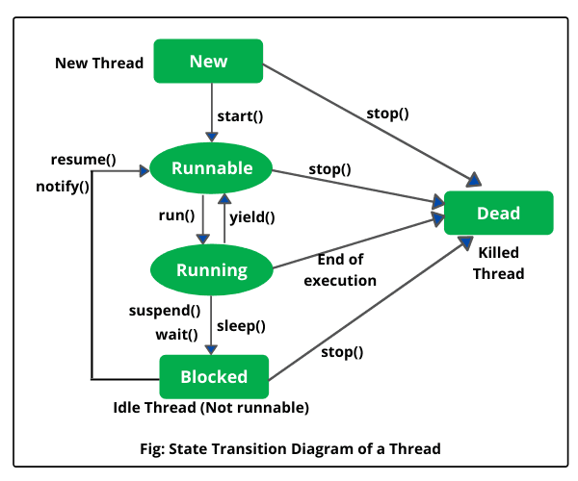

**SR-Annu**  [2:23 PM](https://ncs--program.slack.com/archives/C056KBW1N0M/p1685091230174209)

Develop Single Page Application using Angular based upon following instructions

1. Create User Registration Page with following fields

2. User Registration Page Implementation

d. While registering, customer need to provide the following information

i. Email-id – (@Id)

ii. Name

iii. Address

iv. Account no.

v. Mobile no.

vi. Password

e. You should implement the validation for the above fields in which email id should accept only valid email id format (xxx@xx.com), mobile number should be 10 digits, name can't be empty, password can't be empty.

3. Once successfully entered the details it displays "Registration completion" message

4. Create Login Page with following fields

a. For login user must enter following details

i. Email-id

ii. Password

b. Once successfully entered the details it should redirect to home page on successful login

5. Use can use Angular, Material and Bootstrap

**SR-Annu**  [2:57 PM](https://ncs--program.slack.com/archives/C056KBW1N0M/p1685093257400929)

<https://www.linkedin.com/posts/brijpandeyji_linux-upskilling-softwareengineering-activity-7067154943165485056-GN5s?utm_source=share&utm_medium=member_android>

**linkedin.com**

[**Brij kishore Pandey on LinkedIn: #linux #upskilling #softwareengineering | 78 comments**](https://www.linkedin.com/posts/brijpandeyji_linux-upskilling-softwareengineering-activity-7067154943165485056-GN5s?utm_source=share&utm_medium=member_android)

If you&#39;re an IT professional, navigating the Linux file system is a skill that can take you far.It&#39;s meticulously organized - like a well-structured… | 78 comments on LinkedIn (103 kB)

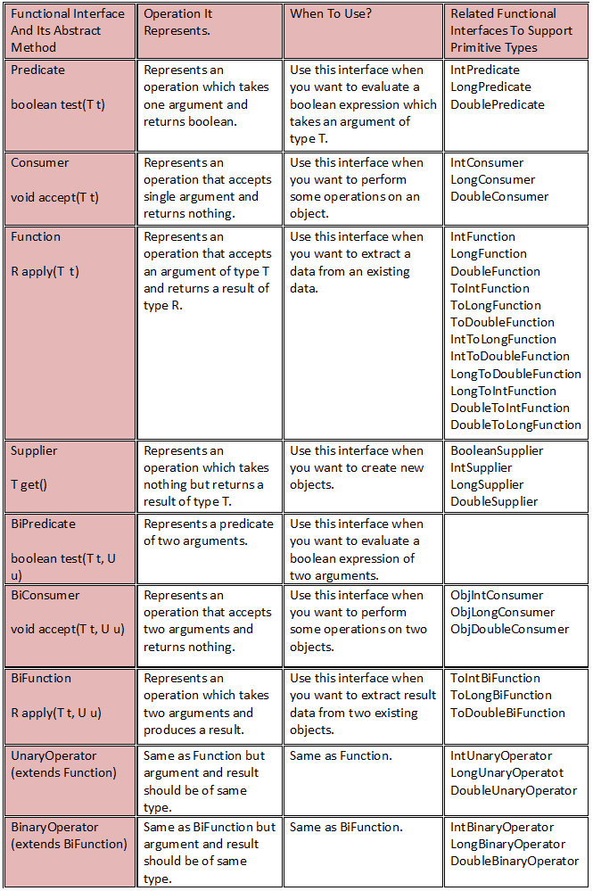

**SR-Annu**  [8:08 AM](https://ncs--program.slack.com/archives/C056KBW1N0M/p1685414330060669)

<https://www.analyticsinsight.net/functional-programming-a-proven-method-for-experienced-programmers/>

**Analytics Insight**

[**Functional Programming: A Proven Method for Experienced Programmers**](https://www.analyticsinsight.net/functional-programming-a-proven-method-for-experienced-programmers/)

Unlock the potential of functional programming for experienced programmers and dive into functional programming languages, pure functions, and software development.

**Written by**

Samarpita Chakraborty

**Est. reading time**

5 minutes

May 25th

<https://www.analyticsinsight.net/functional-programming-a-proven-method-for-experienced-programmers/>

[8:12](https://ncs--program.slack.com/archives/C056KBW1N0M/p1685414533161099)

<https://colorlib.com/wp/free-css-website-templates/>

**Colorlib**

[**67 Modern Free CSS Website Templates 2023**](https://colorlib.com/wp/free-css-website-templates/)

This list of the best free CSS website templates is for everyone who would like to create a spectacular and mobile-ready page using CSS.

**Written by**

Aigars Silkalns

**Est. reading time**

55 minutes

**SR-Annu**  [11:54 AM](https://ncs--program.slack.com/archives/C056KBW1N0M/p1685514279448509)

<https://spring.io/tools>

**spring.io**

[**Tools**](https://spring.io/tools)

Spring Tools 4 is the next generation of Spring tooling for your favorite coding environment. Largely rebuilt from scratch, it provides world-class support for developing Spring-based enterprise applications, whether you prefer Eclipse, Visual Studio Code, or Theia IDE. (9 kB)

**SR-Annu**  [12:11 PM](https://ncs--program.slack.com/archives/C056KBW1N0M/p1685515308018249)

<https://junit.org/junit5/>

**junit.org**

[**JUnit 5**](https://junit.org/junit5/)

 The 5th major version of the programmer-friendly testing framework for Java and the JVM

[12:14](https://ncs--program.slack.com/archives/C056KBW1N0M/p1685515452766459)

<https://mvnrepository.com/>



**SR-Annu**  [12:22 PM](https://ncs--program.slack.com/archives/C056KBW1N0M/p1685515950026499)

<https://mvnrepository.com/search?q=JUNIT>



**SR-Annu**  [10:06 AM](https://ncs--program.slack.com/archives/C056KBW1N0M/p1685594170168179)

Working with Spring Core, IOC, Spring DAO using JDBC, Spring

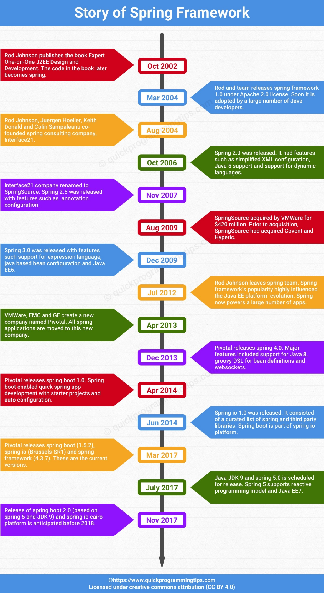

**SR-Annu**  [10:27 AM](https://ncs--program.slack.com/archives/C056KBW1N0M/p1685595424474369)

<https://spring.io/projects>

**spring.io**

[**Projects**](https://spring.io/projects)

Level up your Java code and explore what Spring can do for you. (9 kB)

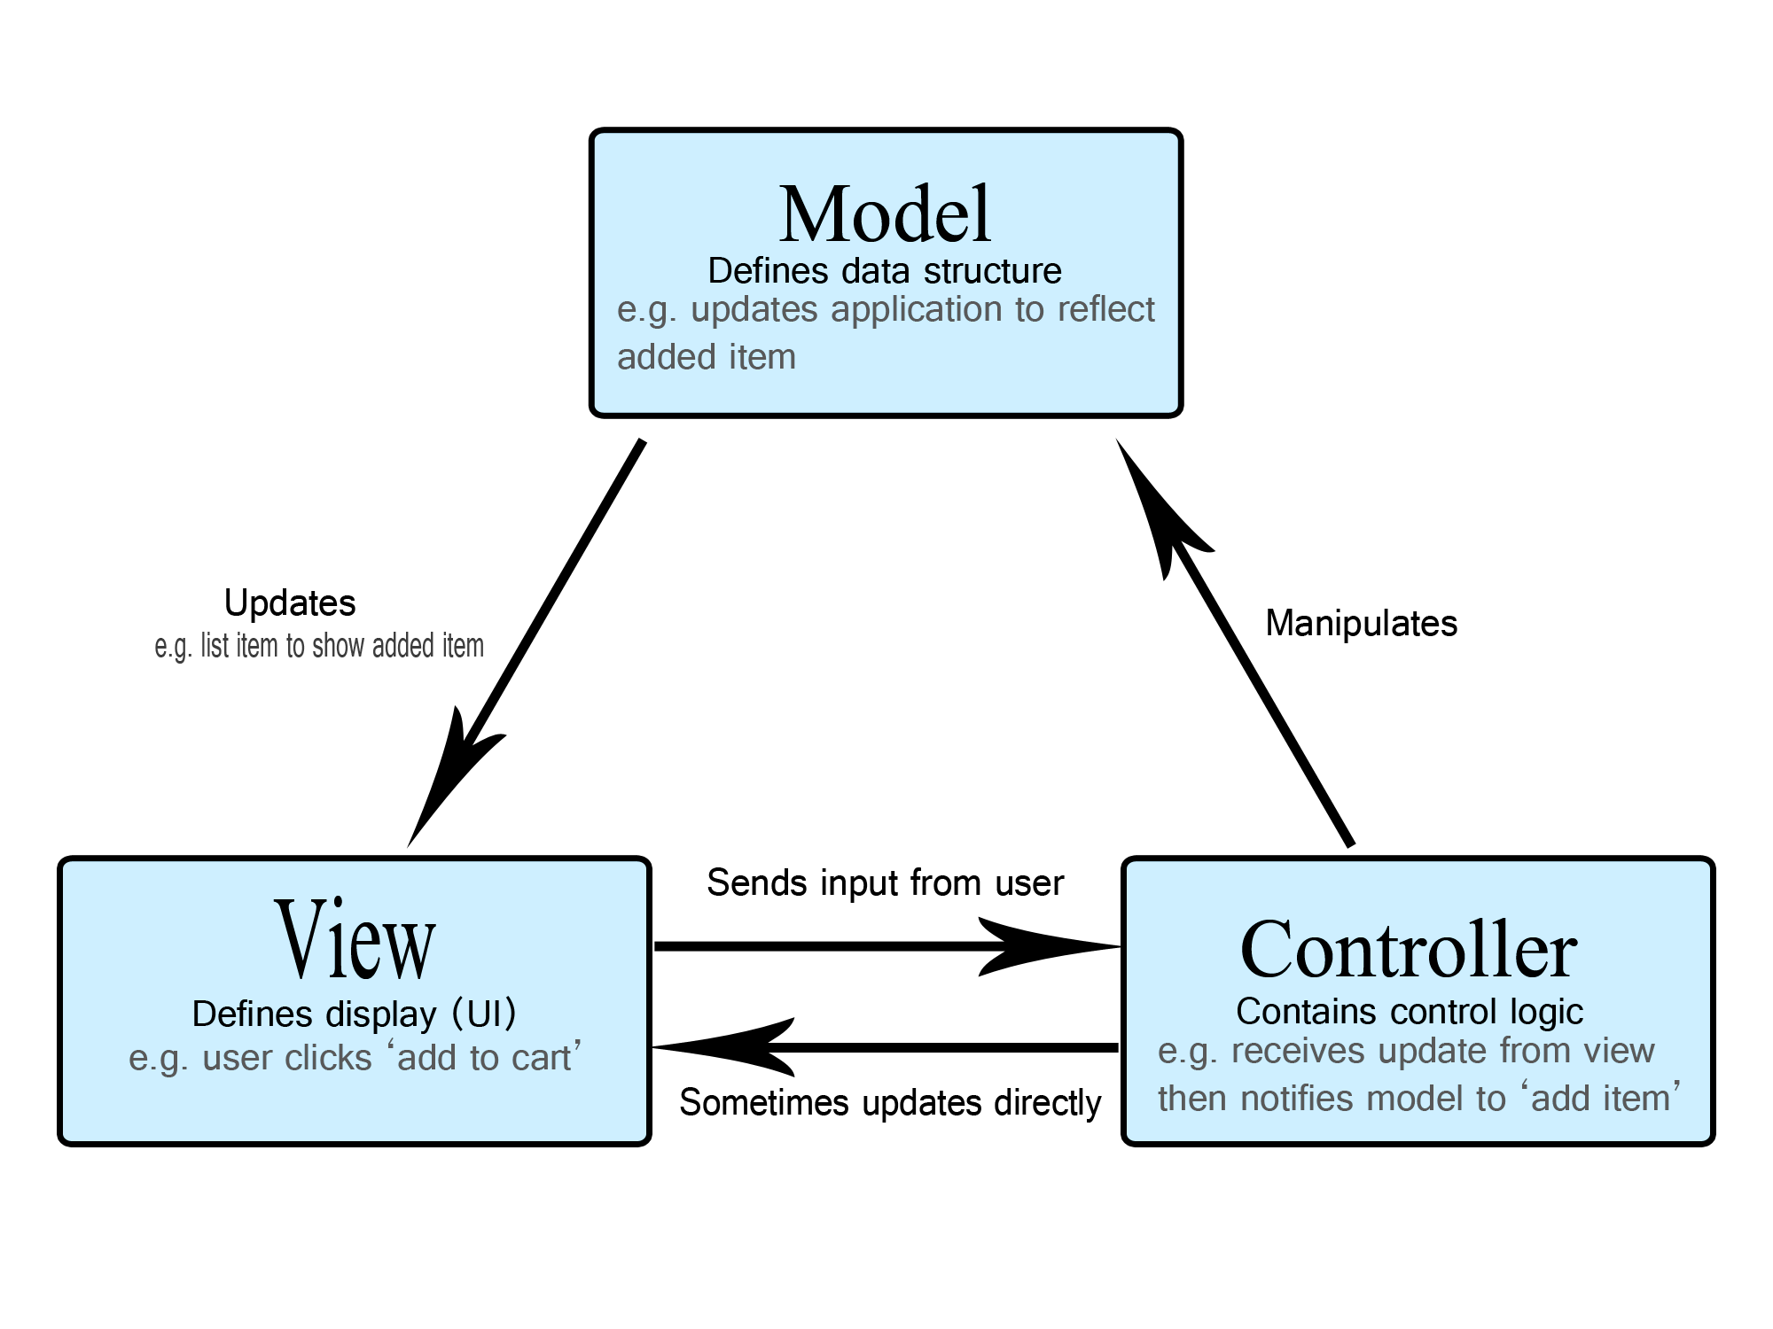

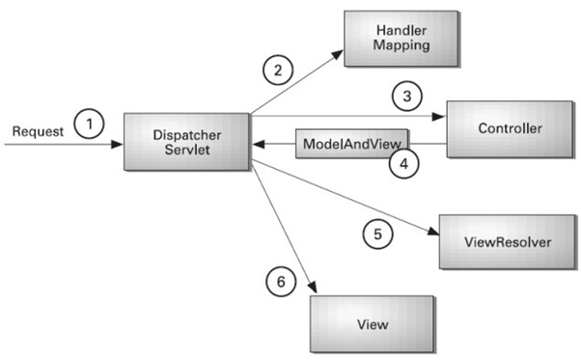

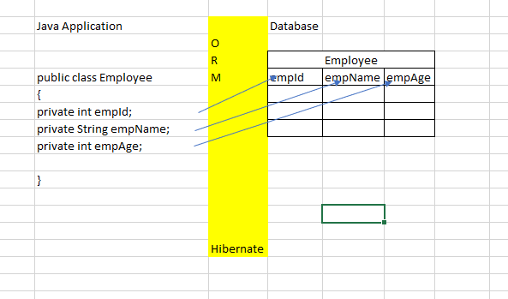

**SR-Annu**  [5:43 PM](https://ncs--program.slack.com/archives/C056KBW1N0M/p1685621606118869)

<https://javatechonline.com/spring-core-mcq-and-answers-explained/>

**JavaTechOnline**

[**Spring Core MCQ And Answers Explained - JavaTechOnline**](https://javatechonline.com/spring-core-mcq-and-answers-explained/)

Spring Core MCQ and Answers Explained

**Written by**

devs5003

**Time to read**

13 minutes

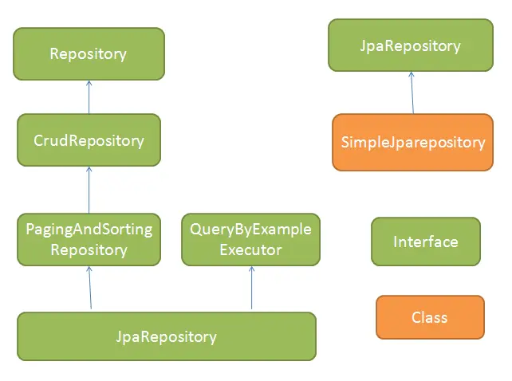

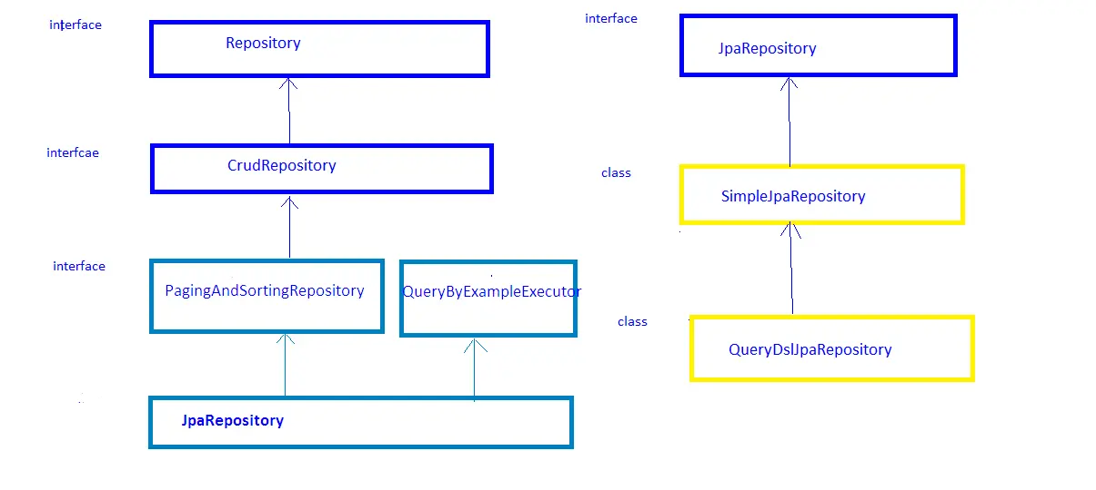

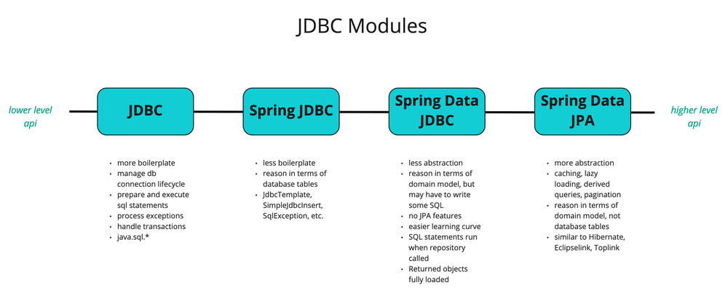

**SR-Annu**  [12:19 PM](https://ncs--program.slack.com/archives/C056KBW1N0M/p1685688588308319)

<https://developer.mozilla.org/en-US/docs/Web/HTTP/Status>

**developer.mozilla.org**

[**HTTP response status codes - HTTP | MDN**](https://developer.mozilla.org/en-US/docs/Web/HTTP/Status)

HTTP response status codes indicate whether a specific HTTP request has been successfully completed.  
Responses are grouped in five classes: (24 kB)

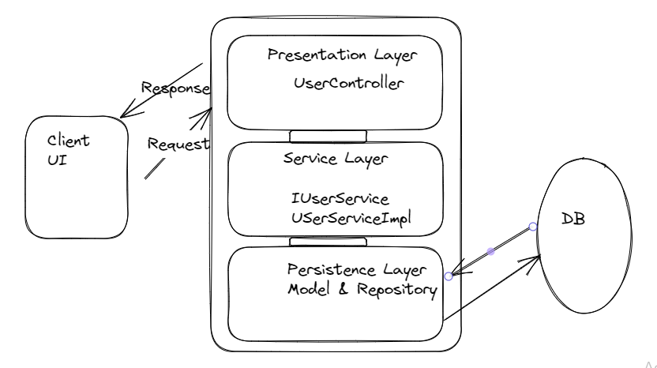

**SR-Annu**  [2:28 PM](https://ncs--program.slack.com/archives/C056KBW1N0M/p1685696282059589)

<https://youtu.be/TWK7-gzTiHk>

[](https://www.youtube.com/)[**YouTube**](https://www.youtube.com/) | [Java Guides](https://www.youtube.com/@JavaGuides)

[**How Spring Boot Application Internally Works | Let's Debug and Understand run() Method Step by Step**](https://youtu.be/TWK7-gzTiHk)

**SR-Annu**  [5:22 PM](https://ncs--program.slack.com/archives/C056KBW1N0M/p1685706760169469)

server.port=8082

spring.data.mongodb.database=noteDB

spring.data.mongodb.uri=<mongodb://localhost:27017/noteDB>

**SR-Annu**  [6:51 AM](https://ncs--program.slack.com/archives/C056KBW1N0M/p1685841664176269)

<https://www.crio.do/blog/understand-mvc-architecture/>

**Crio Blog**

[**Understand MVC Architecture in 5 mins**](https://www.crio.do/blog/understand-mvc-architecture/)

Get to know about Model View Controller Architecture, how it works and why to use it with the help of real life analogies.

**Written by**

Jaidev Singh Bhui

**Filed under**

Web Development

<https://www.freecodecamp.org/news/how-javascript-works-behind-the-scenes/>

**freeCodeCamp.org**

[**How Does JavaScript Work Behind the Scenes? JS Engine and Runtime Explained**](https://www.freecodecamp.org/news/how-javascript-works-behind-the-scenes/)

So you may know that your code somehow compiles and executes in your browser to display the beautiful web application you’ve built. But are you aware of all the components that come into play to enable the output? Let’s dive a little into JavaScript behind the scenes. The abstract

**Written by**

Esther Christopher

**Filed under**

JavaScript

<https://levelup.gitconnected.com/become-a-better-java-developer-master-these-5-creational-design-patterns-4e91e0100e04>

**Medium**

[**Become a Better Java Developer: Master these 5 Creational Design Patterns**](https://levelup.gitconnected.com/become-a-better-java-developer-master-these-5-creational-design-patterns-4e91e0100e04)

Explore and Master 5 Key Java Design Patterns

**Reading time**

11 min read

Jun 1st (69 kB)

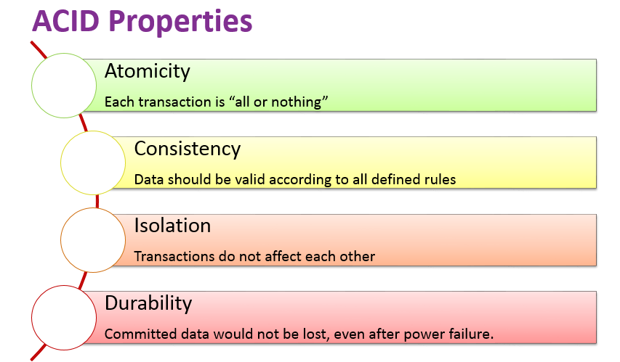

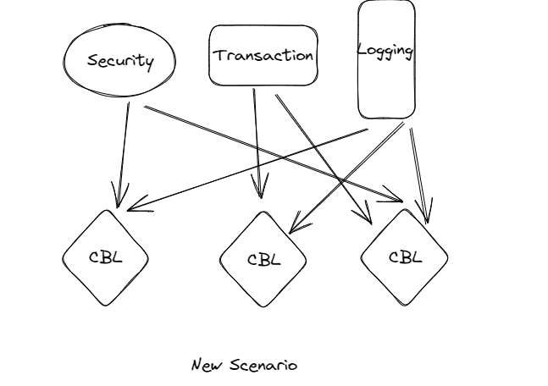

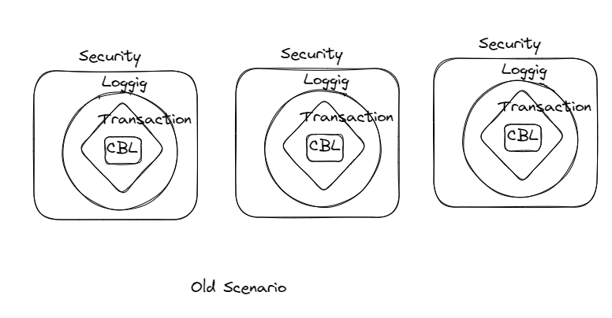

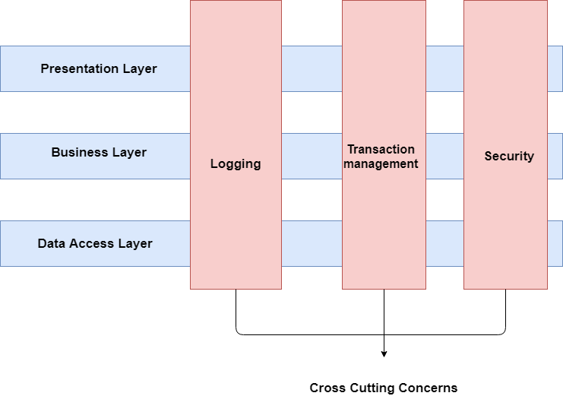

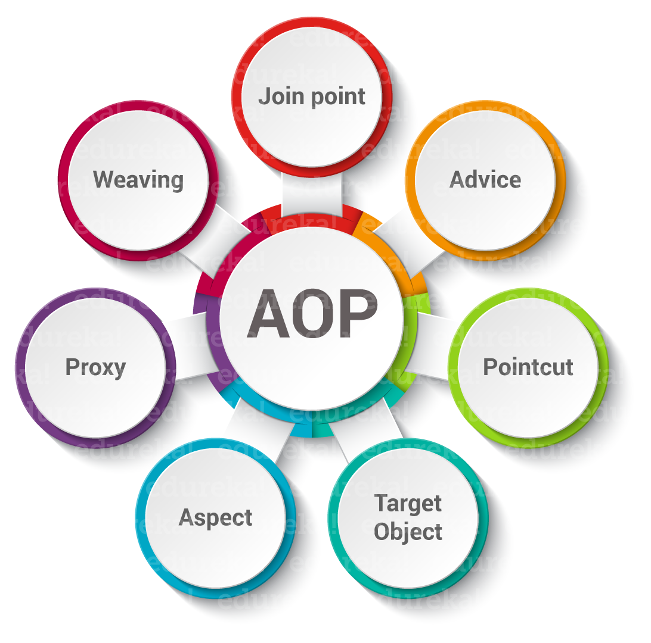

**SR-Annu**  [3:20 PM](https://ncs--program.slack.com/archives/C056KBW1N0M/p1685958622302179)

<https://docs.spring.io/spring-framework/docs/2.5.5/reference/aop.html>

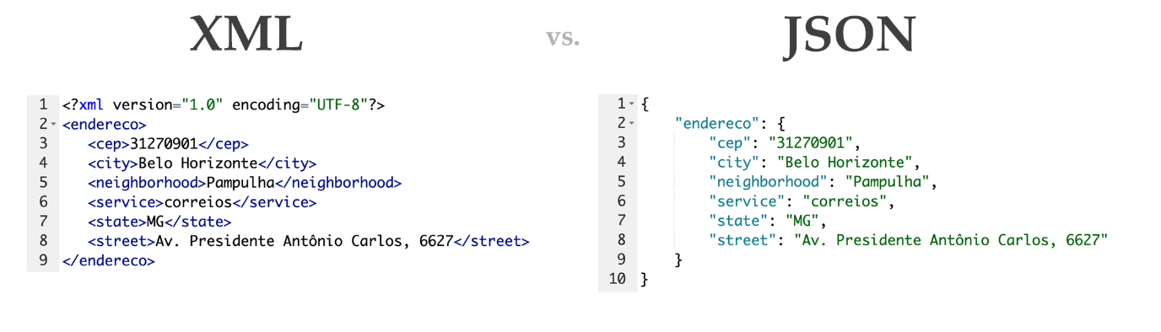

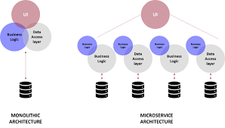

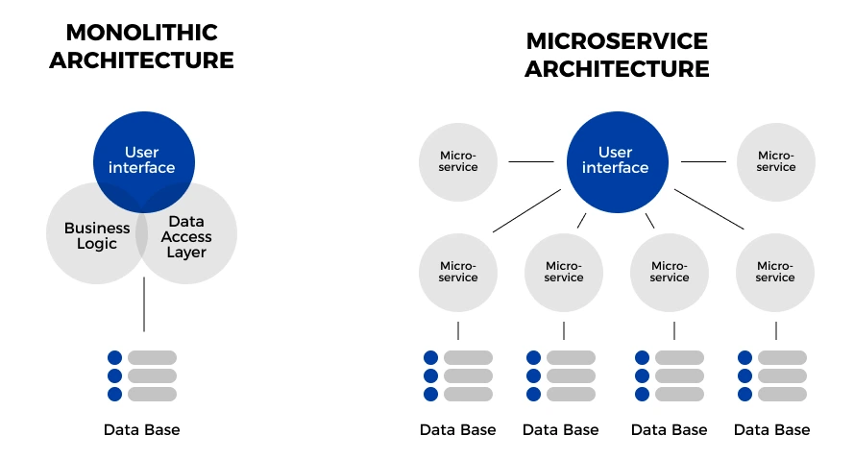

**SR-Annu**  [10:40 AM](https://ncs--program.slack.com/archives/C056KBW1N0M/p1686028250872479)

<https://www.educative.io/answers/what-are-the-solid-principles-in-java>

**Educative: Interactive Courses for Software Developers**

[**What are the SOLID principles in Java?**](https://www.educative.io/answers/what-are-the-solid-principles-in-java)

Contributor: Educative Answers Team

[10:41](https://ncs--program.slack.com/archives/C056KBW1N0M/p1686028278454469)

<https://blog.clearscale.com/12-factor-approach-for-microservices/>

**https://blog.clearscale.com**

[**Using the 12-Factor Approach for Microservices**](https://blog.clearscale.com/12-factor-approach-for-microservices/)

This overview of using the 12 Factor Application methodology includes information specific to microservices architecture.

**Written by**

[anton.gorbachev@clearscale.com](mailto:anton.gorbachev@clearscale.com)

**Est. reading time**

8 minutes

May 11th

[10:41](https://ncs--program.slack.com/archives/C056KBW1N0M/p1686028302230239)

<https://martinfowler.com/tags/domain%20driven%20design.html>

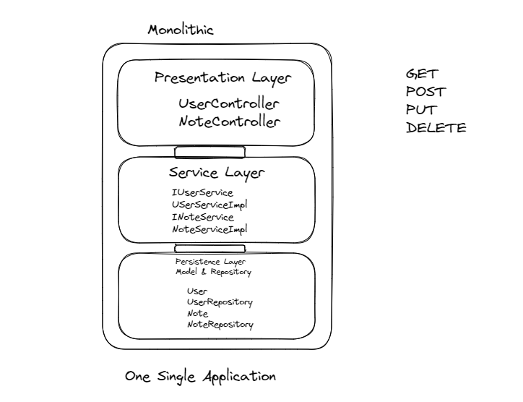

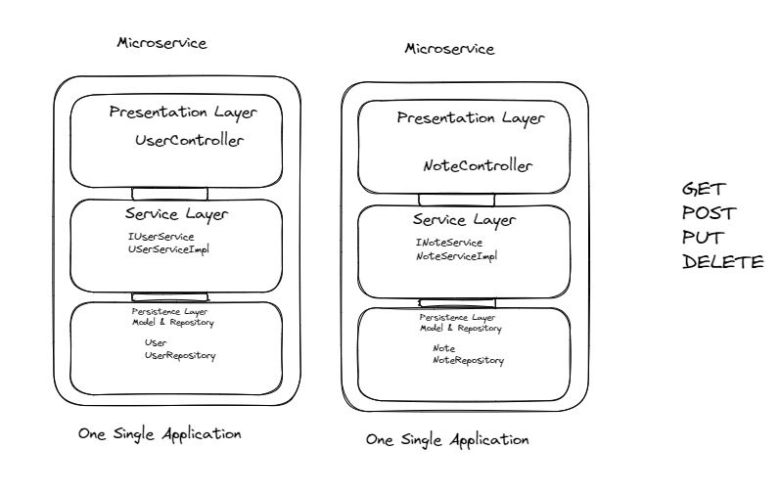

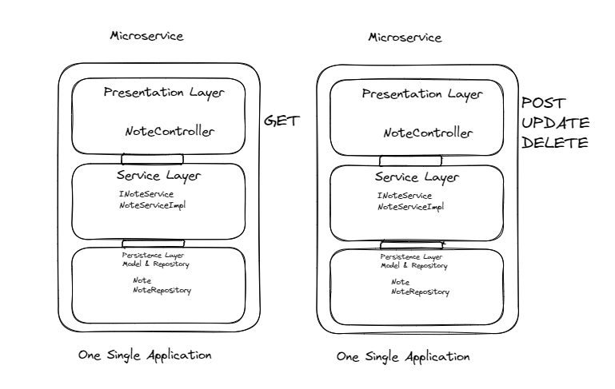

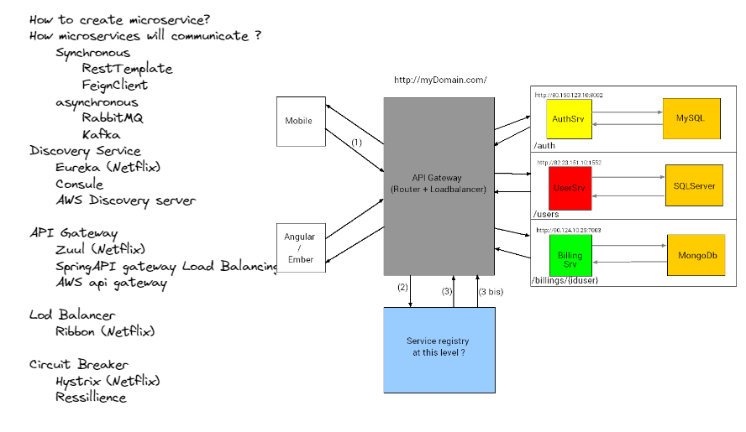

**SR-Annu**  [3:04 PM](https://ncs--program.slack.com/archives/C056KBW1N0M/p1686216857376569)

<https://jwt.io/>

**jwt.io**

[**JWT.IO**](https://jwt.io/)

JSON Web Tokens are an open, industry standard RFC 7519 method for representing claims securely between two parties. (16 kB)

**SR-Annu**  [5:02 PM](https://ncs--program.slack.com/archives/C056KBW1N0M/p1686223971080149)

<!-- <https://mvnrepository.com/artifact/io.jsonwebtoken/jjwt> -->

<dependency>

<groupId>io.jsonwebtoken</groupId>

<artifactId>jjwt</artifactId>

<version>0.9.1</version>

</dependency>

<!-- <https://mvnrepository.com/artifact/javax.xml.bind/jaxb-api> -->

<dependency>

<groupId>javax.xml.bind</groupId>

<artifactId>jaxb-api</artifactId>

<version>2.3.1</version>

</dependency>

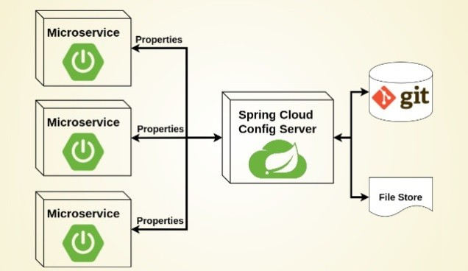

**SR-Annu**  [12:45 PM](https://ncs--program.slack.com/archives/C056KBW1N0M/p1686294944406179)

<https://docs.spring.io/spring-boot/docs/current/actuator-api/htmlsingle/>

**SR-Annu**  [5:04 PM](https://ncs--program.slack.com/archives/C056KBW1N0M/p1686310490291759)

<https://docs.docker.com/desktop/install/windows-install/>

**Docker Documentation**

[**Install Docker Desktop on Windows**](https://docs.docker.com/desktop/install/windows-install/)

Get started with Docker for Windows. This guide covers system requirements, where to download, and instructions on how to install and update.

Jun 9th (28 kB)

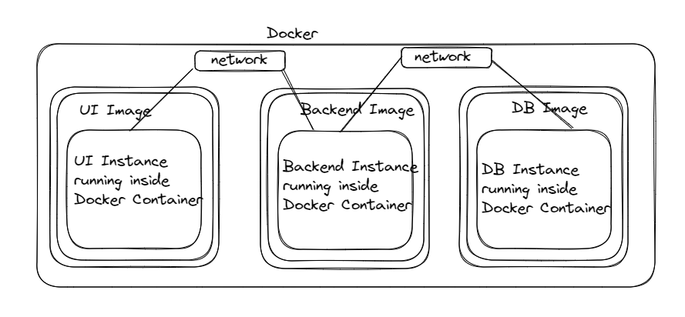

<https://collabnix.com/docker-cheatsheet/>

**collabnix.com**

[**Docker Cheatsheet [2023 Updated]**](https://collabnix.com/docker-cheatsheet/)

A cheatsheet is a concise summary of important information that is meant to be used as a quick reference. Cheatsheets are often used in the form of a list or a table, and they typically cover a specific topic or subject area. In the context of Docker, a Docker cheatsheet is a summary of commonly used Docker commands and their options, as well as other useful information related to Docker.  
Cheatsheets can be particularly helpful when learning a new tool or technology, as they provide a convenient way to quickly look up and remind oneself of key concepts and commands. They can also be useful for experienced users who need to recall a specific command or option but may not remember all the detai… Show more

**SR-Annu**  [2:10 PM](https://ncs--program.slack.com/archives/C056KBW1N0M/p1686559221758989)

Today's recordings are also available for reference

[2:11](https://ncs--program.slack.com/archives/C056KBW1N0M/p1686559313540979)

<https://www.tutorialsteacher.com/mongodb/mongodb-shell-commands>

**tutorialsteacher.com**

[**MongoDB Shell Commands**](https://www.tutorialsteacher.com/mongodb/mongodb-shell-commands)

Learn about MongoDB Shell commands. (3 kB)

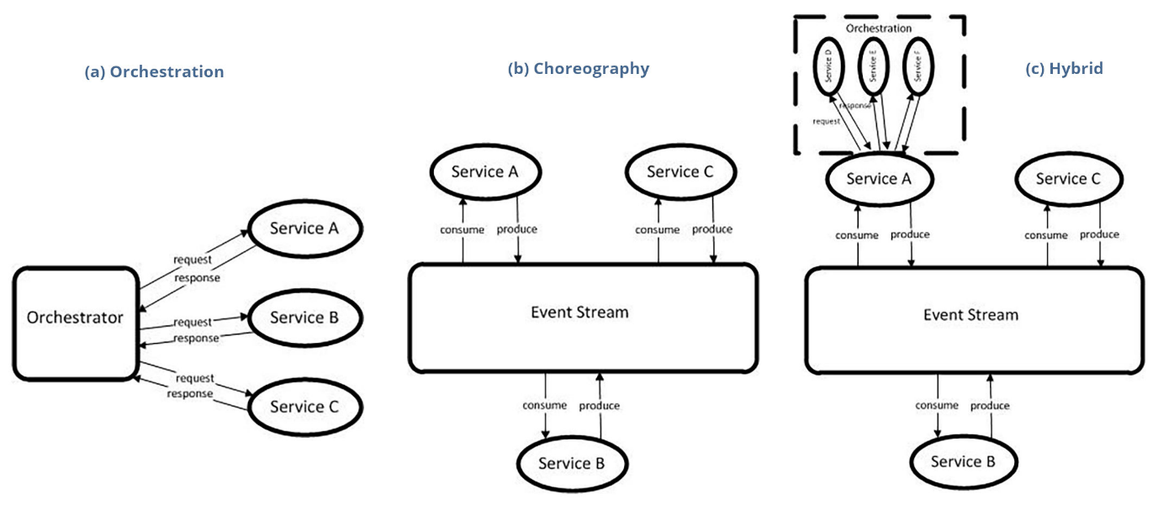

**SR-Annu**  [5:06 PM](https://ncs--program.slack.com/archives/C056KBW1N0M/p1686656190004889)

<https://kafka.apache.org/downloads>

**kafka.apache.org**

[**Apache Kafka**](https://kafka.apache.org/downloads)

Apache Kafka: A Distributed Streaming Platform. (39 kB)

<https://kafka.apache.org/documentation/>

**kafka.apache.org**

[**Apache Kafka**](https://kafka.apache.org/documentation/)

Apache Kafka: A Distributed Streaming Platform. (39 kB)

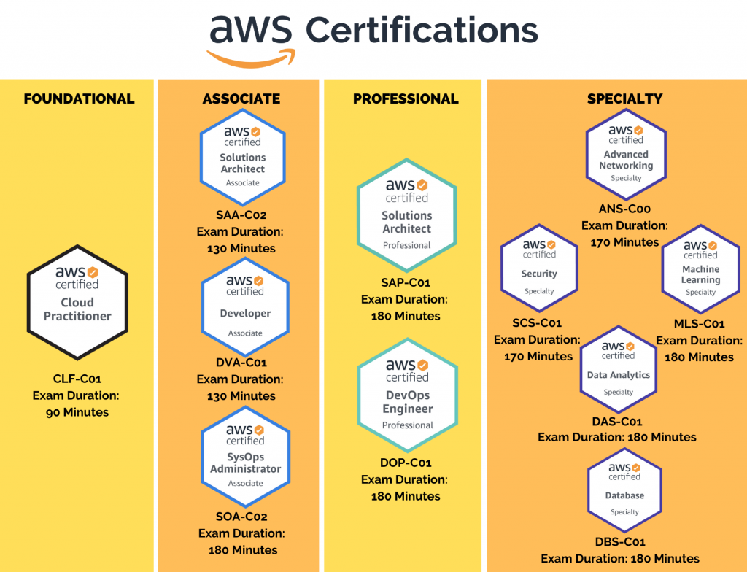

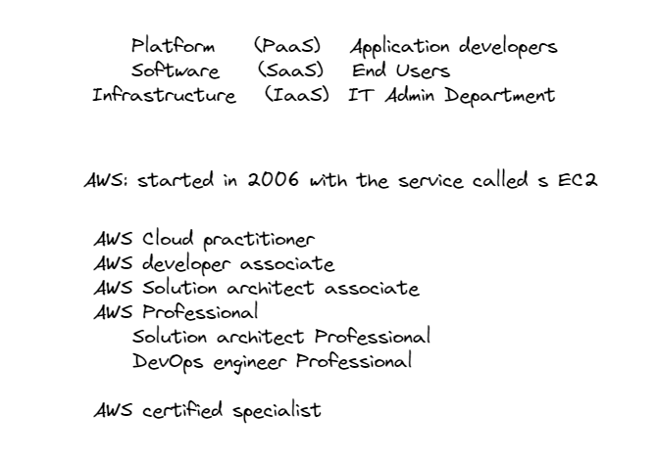

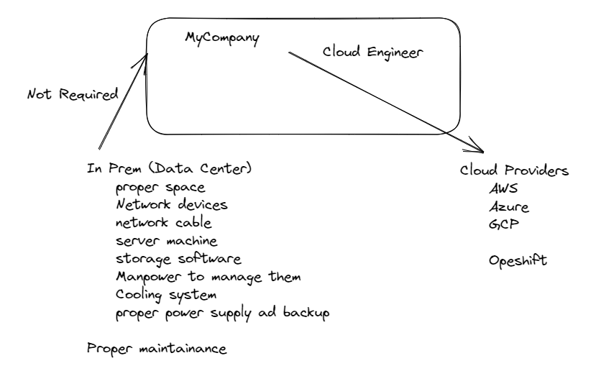

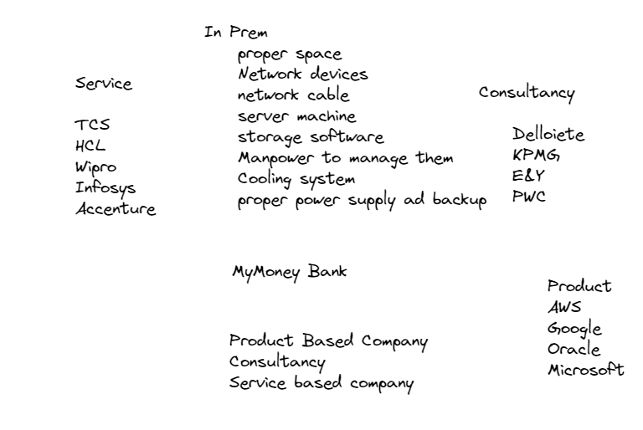

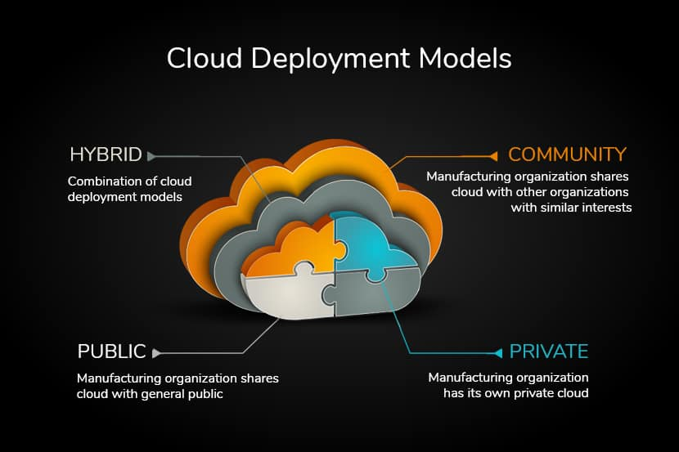

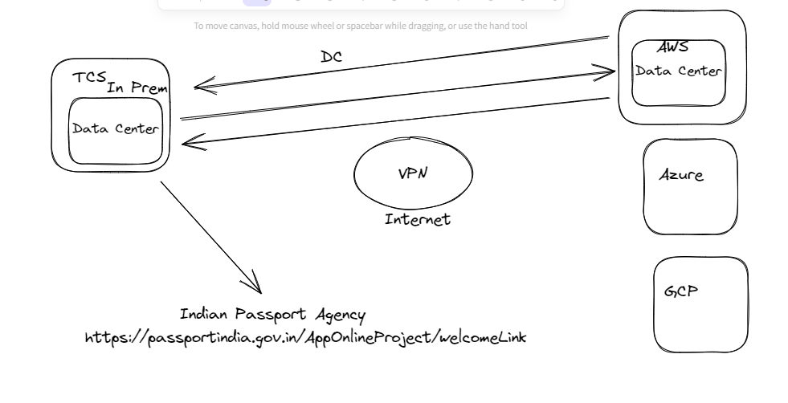

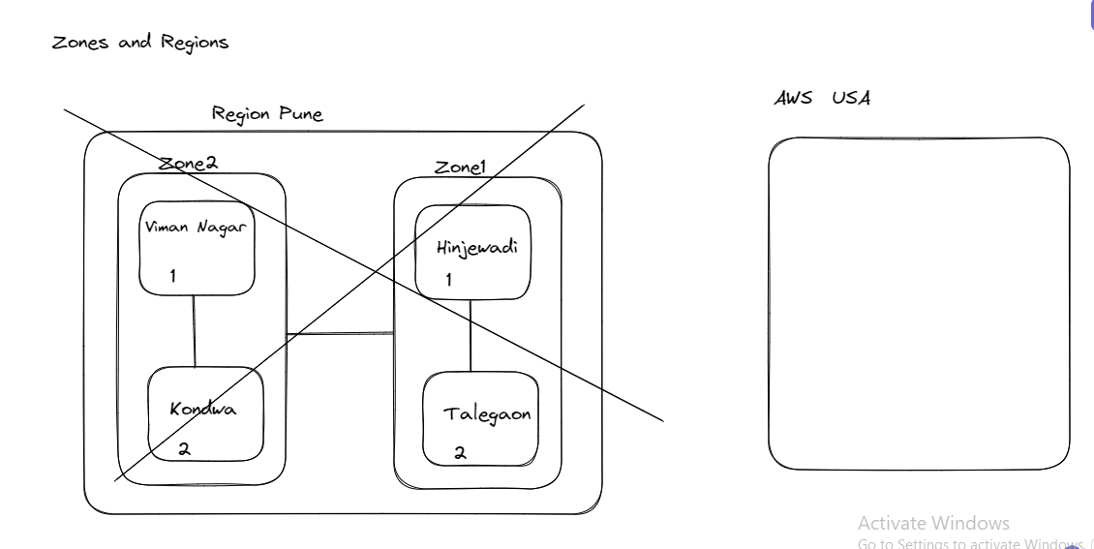

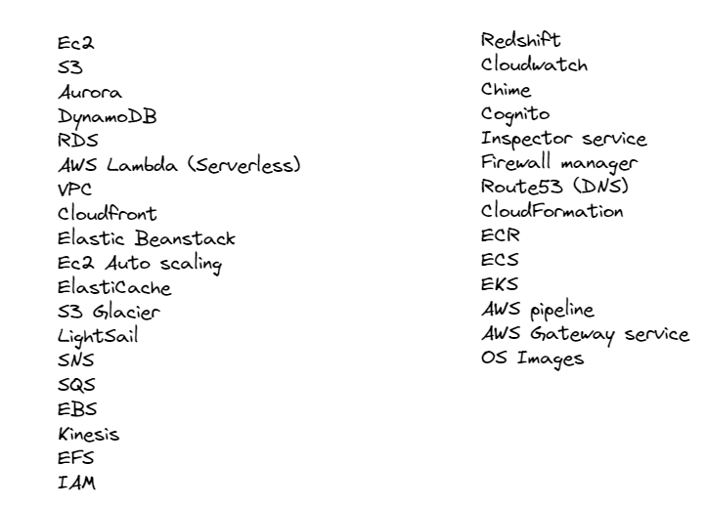

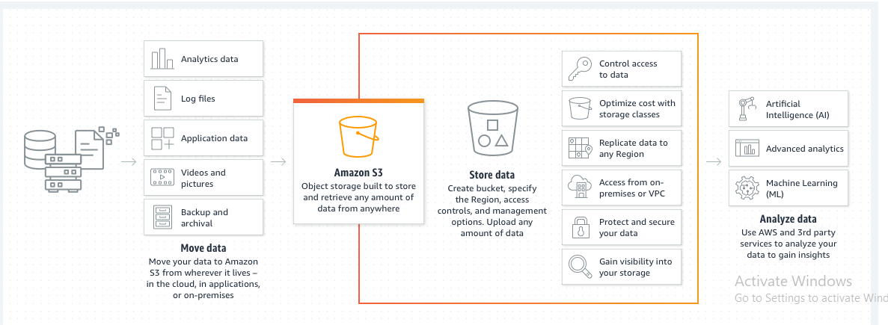

**SR-Annu**  [5:39 PM](https://ncs--program.slack.com/archives/C056KBW1N0M/p1686830950747969)

<https://docs.aws.amazon.com/corretto/latest/corretto-17-ug/amazon-linux-install.html>

**docs.aws.amazon.com**

[**Amazon Corretto 17 Installation Instructions for Amazon Linux 2 and Amazon Linux 2022 - Amazon Corretto 17**](https://docs.aws.amazon.com/corretto/latest/corretto-17-ug/amazon-linux-install.html)

Instructions for installing Amazon Corretto 17 on Amazon Linux

**SR-Annu**  [5:57 PM](https://ncs--program.slack.com/archives/C056KBW1N0M/p1686832049121419)

To access the service running o EC2 try following command

[5:57](https://ncs--program.slack.com/archives/C056KBW1N0M/p1686832056692449)

image.png



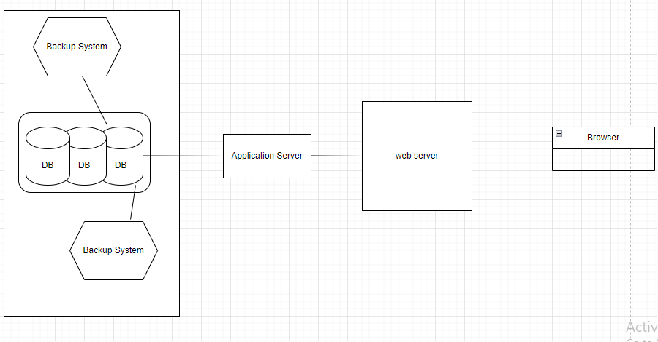

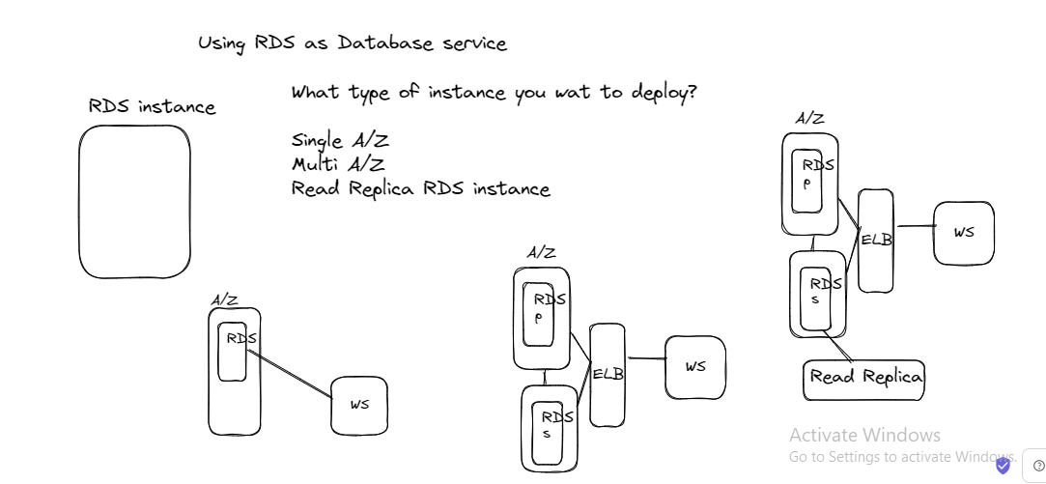

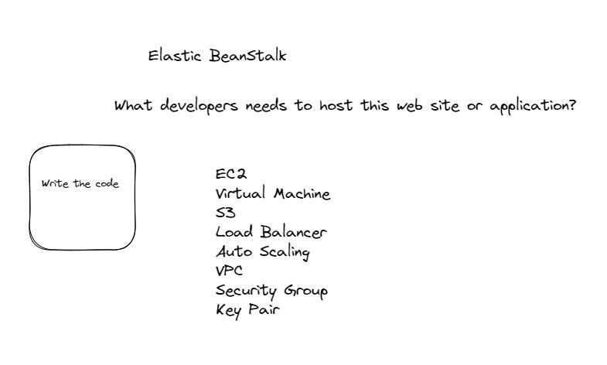

**SR-Annu**  [8:23 AM](https://ncs--program.slack.com/archives/C056KBW1N0M/p1686970420523459)

<https://levelup.gitconnected.com/docker-compose-vs-kubernetes-understanding-the-differences-and-choosing-the-right-tool-32f3e16fdb43>

**Medium**

[**Docker Compose vs. Kubernetes: Understanding the Differences and Choosing the Right Tool**](https://levelup.gitconnected.com/docker-compose-vs-kubernetes-understanding-the-differences-and-choosing-the-right-tool-32f3e16fdb43)

From Local Development to Production Deployments

**Reading time**

21 min read

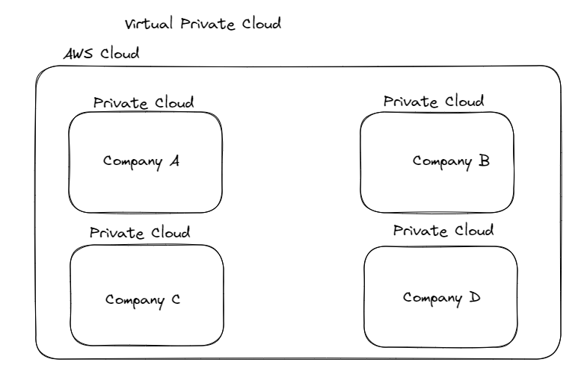

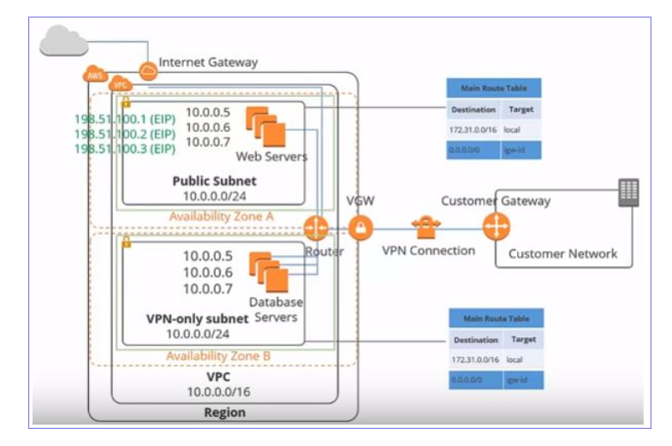

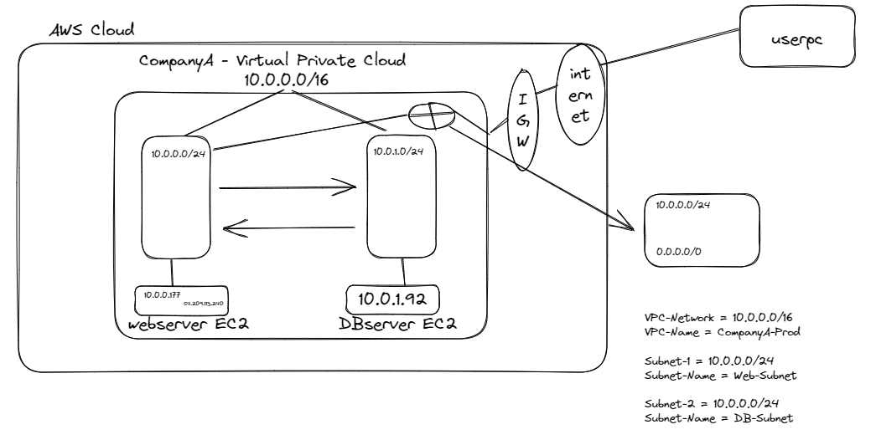

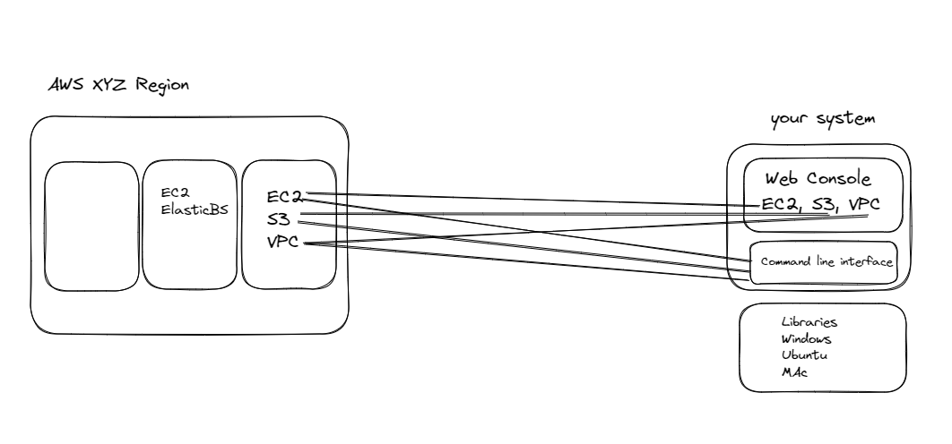

**SR-Annu**  [10:31 AM](https://ncs--program.slack.com/archives/C056KBW1N0M/p1687323690866539)

<https://docs.aws.amazon.com/cli/latest/userguide/getting-started-install.html>

**docs.aws.amazon.com**

[**Installing or updating the latest version of the AWS CLI - AWS Command Line Interface**](https://docs.aws.amazon.com/cli/latest/userguide/getting-started-install.html)

Install the AWS CLI on your system.

[10:31](https://ncs--program.slack.com/archives/C056KBW1N0M/p1687323706527709)

<https://www.bluematador.com/learn/aws-cli-cheatsheet>

**Blue Matador**

[**AWS CLI Cheatsheet | Blue Matador**](https://www.bluematador.com/learn/aws-cli-cheatsheet)

AWS CLI is the command line tool for managing your AWS environment. This cheatsheet can be used as a quick reference for some of the most common commands. (9 kB)

<https://www.bluematador.com/learn/aws-cli-cheatsheet>

[10:34](https://ncs--program.slack.com/archives/C056KBW1N0M/p1687323886915109)

PDF

**[GIT Cheatsheet.pdf](https://ncs--program.slack.com/files/U05712KFLKT/F05DDC65NUD/git_cheatsheet.pdf?origin_team=T0567PEGXK9&origin_channel=C056KBW1N0M" \t "_blank)**

[View](https://ncs--program.slack.com/files/U05712KFLKT/F05DDC65NUD/git_cheatsheet.pdf?origin_team=T0567PEGXK9&origin_channel=C056KBW1N0M" \t "_blank) **[PDF](https://ncs--program.slack.com/files/U05712KFLKT/F05DDC65NUD/git_cheatsheet.pdf?origin_team=T0567PEGXK9&origin_channel=C056KBW1N0M" \t "_blank)** [in Slack](https://ncs--program.slack.com/files/U05712KFLKT/F05DDC65NUD/git_cheatsheet.pdf?origin_team=T0567PEGXK9&origin_channel=C056KBW1N0M" \t "_blank)

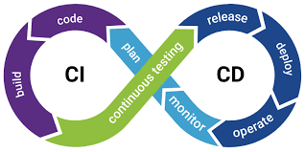

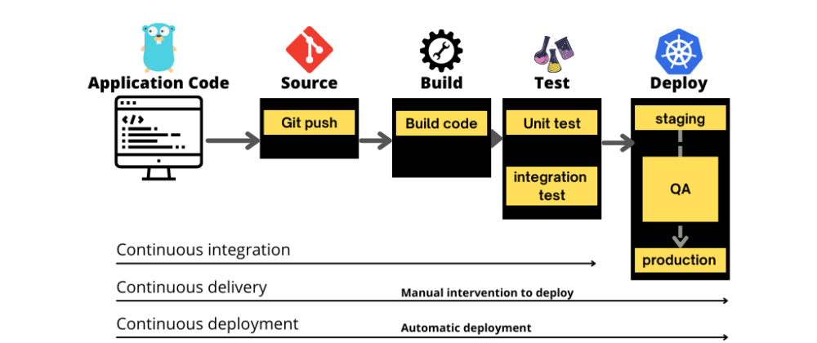

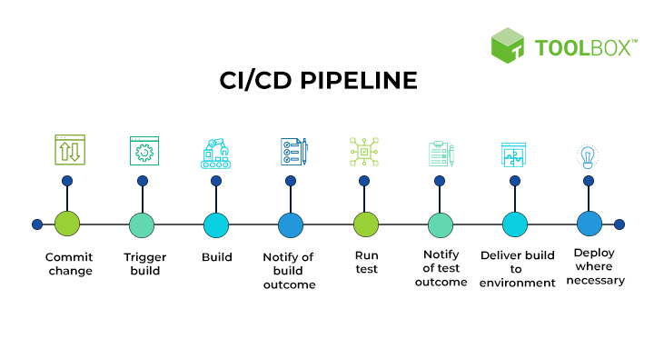

<dependency>

<groupId>org.springframework.boot</groupId>

<artifactId>spring-boot-starter-test</artifactId>

<scope>test</scope>

<exclusions>

<exclusion>

<groupId>

org.junit.vintage

</groupId>

<artifactId>

junit-vintage-engine

</artifactId>

</exclusion>

</exclusions>

</dependency>



**SR-Annu**  [12:42 PM](https://ncs--program.slack.com/archives/C056KBW1N0M/p1687331532480109)

<https://www.jenkins.io/doc/book/installing/windows/>

**jenkins.io**

[**Windows**](https://www.jenkins.io/doc/book/installing/windows/)

Jenkins – an open source automation server which enables developers around the world to reliably build, test, and deploy their software (35 kB)

**SR-Annu**  [3:19 PM](https://ncs--program.slack.com/archives/C056KBW1N0M/p1687340955492799)

sudo apt-get update

[3:23](https://ncs--program.slack.com/archives/C056KBW1N0M/p1687341201350049)

sudo apt install maven -y

[3:24](https://ncs--program.slack.com/archives/C056KBW1N0M/p1687341260790699)

sudo apt install openjdk-17-jdk

[3:24](https://ncs--program.slack.com/archives/C056KBW1N0M/p1687341282286479)

sudo apt install openjdk-17-jre

[3:27](https://ncs--program.slack.com/archives/C056KBW1N0M/p1687341469177519)

<https://www.jenkins.io/doc/book/installing/linux/>

**jenkins.io**

[**Linux**](https://www.jenkins.io/doc/book/installing/linux/)

Jenkins – an open source automation server which enables developers around the world to reliably build, test, and deploy their software (35 kB)

<https://www.jenkins.io/doc/book/installing/linux/>

**Thursday, June 22nd**



**SR-Annu**  [10:37 AM](https://ncs--program.slack.com/archives/C056KBW1N0M/p1687410459520269)

pipeline {

agent any

tools{

maven 'Maven3'

}

stages {

stage('Checkout') {

steps {

echo 'Readig the repo and making it ready'

checkout scmGit(branches: [[name: '\*/master']], extensions: [], userRemoteConfigs: [[url: '[https://github.com/annurepo/SpringBootRestfulTestingDemo.git']]](https://github.com/annurepo/SpringBootRestfulTestingDemo.git'%5d%5d))

}

}

stage('Clean') {

steps {

echo 'Clean the repo'

bat 'mvn clean'

}

}

stage('Build') {

steps {

echo 'Hello World'

bat 'mvn install'

}

}

stage('Test') {

steps {

echo 'Hello World'

bat 'mvn test'

}

}

}

}



**SR-Annu**  [3:05 PM](https://ncs--program.slack.com/archives/C056KBW1N0M/p1687426502497759)

<https://www.geeksforgeeks.org/java-servlet-filter-with-example/>

**GeeksforGeeks**

[**Java Servlet Filter with Example - GeeksforGeeks**](https://www.geeksforgeeks.org/java-servlet-filter-with-example/)

A Computer Science portal for geeks. It contains well written, well thought and well explained computer science and programming articles, quizzes and practice/competitive programming/company interview Questions.

Jan 28th, 2022

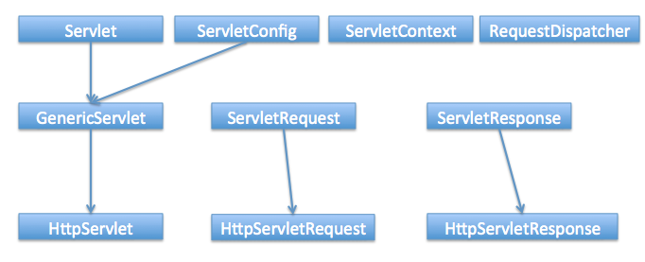

**SR-Annu**  [10:43 AM](https://ncs--program.slack.com/archives/C056KBW1N0M/p1687497180626879)

<https://kubernetes.io/docs/setup/>

**Kubernetes**

[**Getting started**](https://kubernetes.io/docs/setup/)

Production-Grade Container Orchestration

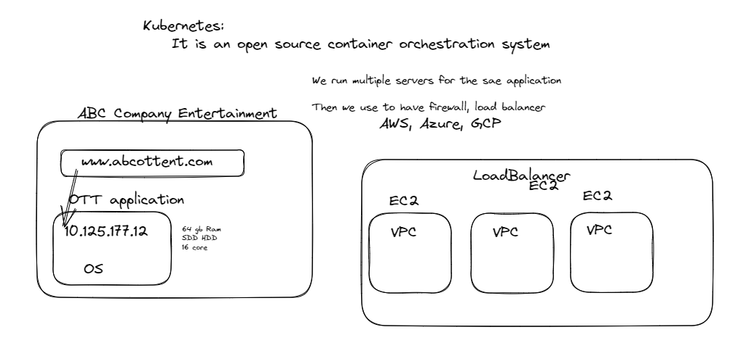

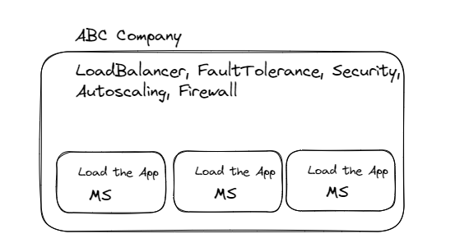

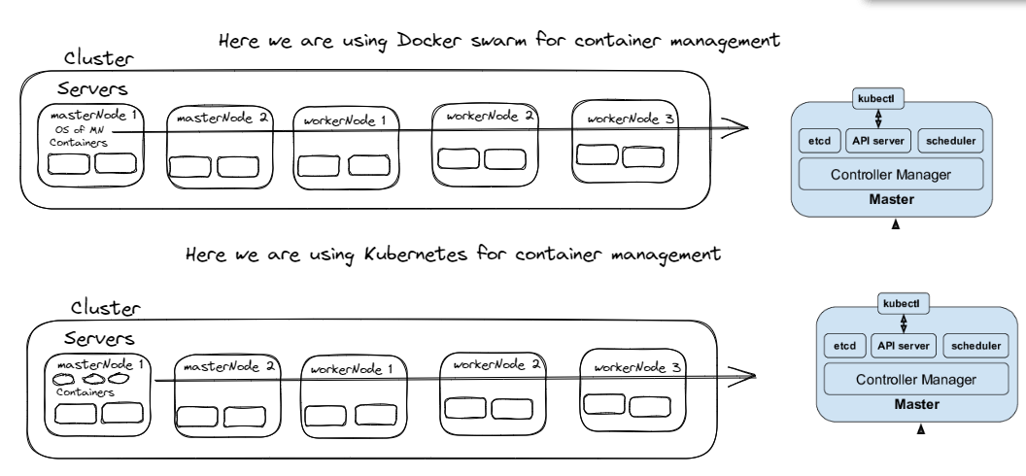

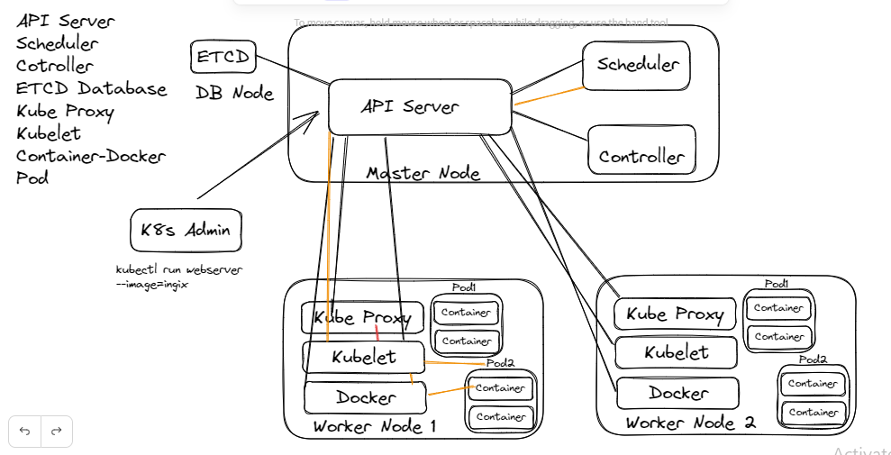

From Admin System Request will go to API Server for creating the container

Let's see How this request will be handled by Kubernetes System::

API server will give it to Scheduler. It is the responsibility of the scheduler to schedule the this request on

particular node. After deciding the node to work with scheduler will informthe kubelet which is available on that

node to create the container Kubelet will create the pod and tell the docker to create the container

Docker will create the container by pulling the required image ad inform the

kubelet then kubelet will response to scheduler

Kubelet will tell the kubeproxy for network setup in the pod and then after that one

IP will be assigned to Pod and this information will go to scheduler

Now Scheduer will inform the database through API server that there is pod

created and then database will update the information related to pod inside the DB

Again Scheduler through API server will update the controller about her creation of pods nd containers

then it is responsibility of controller to make the system always up ad running. If any container is down

controller will take care of that container ad make available the replica of the container

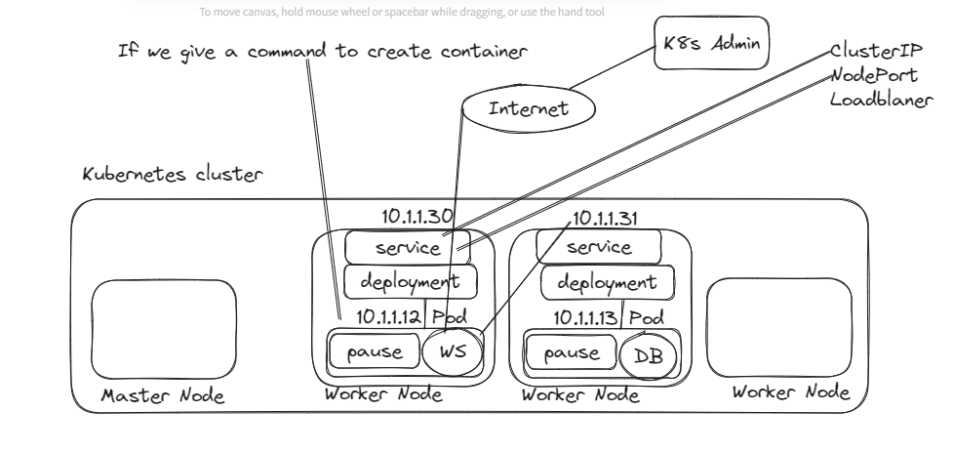

**SR-Annu**  [4:33 PM](https://ncs--program.slack.com/archives/C056KBW1N0M/p1687604609324149)

<https://spacelift.io/blog/docker-commands-cheat-sheet>

**Spacelift**

[**Docker Cheat Sheet - 36 Docker CLI Commands**](https://spacelift.io/blog/docker-commands-cheat-sheet)

This Docker cheat sheet include a quick reference to all the important CLI commands you need when using Docker! (86 kB)

**SR-Annu**  [10:28 AM](https://ncs--program.slack.com/archives/C056KBW1N0M/p1687755536853889)

<https://github.com/yaml/yamlscript>

**GitHub**

[**GitHub - yaml/yamlscript: Programming in YAML**](https://github.com/yaml/yamlscript)

Programming in YAML. Contribute to yaml/yamlscript development by creating an account on GitHub. (43 kB)

**SR-Annu**  [10:49 AM](https://ncs--program.slack.com/archives/C056KBW1N0M/p1687756779079139)

kind: Deployment

apiVersion: extensions/v1beta1

metadata:

name: nginx-deployment

spec:

# A deployment's specification really only

# has a few useful options

# 1. How many copies of each pod do we want?

replicas: 3

# 2. How do want to update the pods?

strategy: Recreate

# 3. Which pods are managed by this deployment?

selector:

# This must match the labels we set on the pod!

matchLabels:

deploy: example

# This template field is a regular pod configuration

# nested inside the deployment spec

template:

metadata:

# Set labels on the pod.

# This is used in the deployment selector.

labels:

deploy: example

spec:

containers:

- name: nginx

image: nginx:1.7.9

**SR-Annu**  [9:00 AM](https://ncs--program.slack.com/archives/C056KBW1N0M/p1687836657042359)

<https://blog.knoldus.com/spring-cloud-gateway-with-jwt/>

**Knoldus Blogs**

[**Spring Cloud Gateway Security with JWT**](https://blog.knoldus.com/spring-cloud-gateway-with-jwt/)

Security,As we all know that everything that is on the Internet need security. Especially when you create software and work with sensitive user data, such as em

**Written by**

Vaishali Yadav

**Est. reading time**

4 minutes

[:04](https://ncs--program.slack.com/archives/C056KBW1N0M/p1687836866240519)

<https://er-akashgupta27.medium.com/api-access-control-with-spring-cloud-gateway-and-oauth2-resource-server-b9049492a798>

[9:06](https://ncs--program.slack.com/archives/C056KBW1N0M/p1687836984224879)

<https://github.com/umesh-kushwaha/jwt-authentication-with-spring-cloud-gateway-sample>

**GitHub**

[**GitHub - umesh-kushwaha/jwt-authentication-with-spring-cloud-gateway-sample: This is a sample application to create and demonstrate the micro-service architecture with spring cloud gateway, eureka server, eureka client, ribbon and feign.**](https://github.com/umesh-kushwaha/jwt-authentication-with-spring-cloud-gateway-sample)

This is a sample application to create and demonstrate the micro-service architecture with spring cloud gateway, eureka server, eureka client, ribbon and feign. - GitHub - umesh-kushwaha/jwt-authen... (157 kB)

**SR-Annu**  [10:45 AM](https://ncs--program.slack.com/archives/C056KBW1N0M/p1687842901134179)

<https://docs.aws.amazon.com/cli/latest/userguide/getting-started-install.html>

**docs.aws.amazon.com**

[**Installing or updating the latest version of the AWS CLI - AWS Command Line Interface**](https://docs.aws.amazon.com/cli/latest/userguide/getting-started-install.html)

Install the AWS CLI on your system.

[10:46](https://ncs--program.slack.com/archives/C056KBW1N0M/p1687842968026149)

<https://kubernetes.io/docs/tasks/tools/install-kubectl-windows/>

**Kubernetes**

[**Install and Set Up kubectl on Windows**](https://kubernetes.io/docs/tasks/tools/install-kubectl-windows/)

Before you begin You must use a kubectl version that is within one minor version difference of your cluster. For example, a v1.27 client can communicate with v1.26, v1.27, and v1.28 control planes. Using the latest compatible version of kubectl helps avoid unforeseen issues.  
Install kubectl on Windows The following methods exist for installing kubectl on Windows:  
Install kubectl binary with curl on Windows Install on Windows using Chocolatey, Scoop, or winget Install kubectl binary with curl on Windows Download the latest 1.

[10:46](https://ncs--program.slack.com/archives/C056KBW1N0M/p1687842994668199)

<https://docs.aws.amazon.com/eks/latest/userguide/eksctl.html>

**docs.aws.amazon.com**

[**Installing or updating eksctl - Amazon EKS**](https://docs.aws.amazon.com/eks/latest/userguide/eksctl.html)

Learn how to install or update the eksctl command line tool. This tool is used to create and work with an Amazon EKS cluster.